*for those able, please stand

Gathering Music & Lighting of Candles

Centering Silence & Prayer

Prelude

Words of Welcome
This is the day that our God has made…
let us rejoice and be glad in it!

*Opening Song
“Woke up this Mornin’
African-American Spiritual

I woke up this morning with my mind
Stayed on Jesus
Hallelu, Hallelu, Hallelujah

Walking and talking… Praying and singing…
Loving my neighbor…

Preparing our Hearts

Reading
“One Day”
Rev. Dr. Martin Luther King Jr.

Gospel Ensemble
“Go Tell It on the Mountain” Peter, Paul & Mary

Reading
“Letter From Birmingham Jail” (excerpt)
Rev. Dr. Martin Luther King Jr.

A Time of Offering & Opportunity

God is good …. all the time…
and all the time…God is good!

Offertory Music “We Shall Not Be Moved”

Children’s Time
I am a child of God,
nothing can shake my confidence;
I am a child of God,
no one can take my inheritance;
Never alone I’ll stand,
strengthened by God’s own hand,
I am a child, I am a child, a child of God.

Bible Bits & Scripture
Isaiah 42:1-9 Matthew 3:13-17

Sermon
“Beginning With Beloved”

Silent Reflection

Song of Response (2x)

Guide my feet while I run this race,
Guide my feet while I run this race,
Guide my feet while I run this race,
For I don’t want to run this race in vain!

A Time of Prayer & Blessing
God in your grace… Hear Our Prayers
You are welcome to come forward for a blessing of beloved-ness and/or to light a candle as a
symbol of your prayer.

*The Prayer of Jesus
(as created at Riverside by members of the
“Greatest Prayer” reflection group)
O Giver of all life,
clear a space within us for your light to dwell.
Create your holy reign of justice and love here today, on Earth,
through our fiery hearts and willing hands.
Give us the bread and strength we need for this day.
Forgive us the harm that we do to all that you love,
as we forgive those who harm us.
And lead us not into numbness, distraction, or greed,
but bring us back from our fears.
For You are the source of all that is good and holy—now and forever.
Amen.

*Closing Song
“Lift Every Voice and Sing” #729

*Benediction

*Choral Response
“Amen”
African American Spiritual
Rev. Vicky Stifter | Minister
Katie Cook | Youth Program Coordinator – Kristin Daly | Nursery Care
Tim Mayer | Piano – Paul Thompson |Bass – Riverside Gospel Ensemble
Donna McCoy & Sandy Spellecy | Greeters
John Boostra, Sandy Spellecy | Readers
Kim Vogel | Audio Visual & Sound System
Jo Herring & Barb Dworschak| Hospitality

Welcome! We are blessed by your presence.
Guests ~ we invite you to fill out a welcome card and place it in the offering plate or give it to Pastor Vicky after the service.

This Week at Riverside
Today
Children - Please join Katie Cook for Sunday School after
Children's Time. No nursery care today.
All are invited after worship for a time of coffee, connection & refreshments in the Riverview Room.

Today’s Meetings
Informational Session in preparation for Annual Meeting – Ruth Wells Room
Listening Session with Beth Hartwell, Sanctuary
Adult Education/Spiritual Nurture Board, Fireside Room

***
Riverside Office
Kathryn is on vacation Jan 13 – 20. Office hours: Tues 1/20 1-3 PM

MONDAY
Martin Luther King Jr. Celebration
Freedom Choir Rehearsal at 1:45 PM | Panel Discussion at 3 PM
Musical Celebration at 5 PM | Community Meal at 6:30 PM.

Wednesday
Bible Study at Parkhurst 2:00 - 3:00 PM
Meditative Prayer 3:30 PM
***
Somos Inmigrantes action in support of our immigrant neighbors. 12th and May Streets. 4 – 5 PM.
Stop by when you can!
***
Choir Rehearsal 6:30 PM
***

Friday
Those of all ages are invited to an interfaith gathering for peace with justice in Palestine. 4:30– 5:00 PM at 2nd and State streets in Hood River.
***
NEXT SUNDAY

RCC Annual Meeting January 25 at noon.
All Riverside members and friends are invited to participate as we celebrate our ministry in 2025 and make important decisions for the year ahead including leadership, budget, and RCC bylaws. Potluck - bring a dish to share!

Welcome to Riverside Community Church
United Church of Christ

WHO WE ARE
We are a vibrant, Spirit-filled community following the ways of Jesus-loving our neighbors, seeking justice, and sharing God's extravagant welcome.

Open and Affirming
We fully embrace LGBTQ+ individuals in all aspects of church life and ministry.

Immigrant Welcoming
We stand in solidarity with our immigrant siblings, documented and undocumented.

Caring for Creation
We divest from fossil fuels, invest in renewable energy, and strive to reduce our environmental impact.

Ministries & Community Engagement
Youth Ministry - Sunday School, teen groups, and Our Whole Lives (OWL), a comprehensive human sexuality program. Contact: Katie Cook 541-980-0505 or katie@riversideucc.com

Justice & Witness
Engaging in advocacy & service
Contact: Jeannie Chance 541-806-6648 stjechance@gmail.com

“Cheers" Care Team
RIVERSIDE COMMUNITY CHURCH
United Church of Christ
January 18, 2026
Providing meals and support during times of transition
and challenge.
Contact: Pastor Vicky 541-386-1412 pastor@riversideucc.com

Connect & Grow
Men's Discussion Group
Monthly Book Group
Adult Education Classes
Bible Study & Reflection

Stay Connected
Weekly Newsletter, The Current
Sign up at kathy@hungerchronicles.com
Follow Us on Facebook - Riverside Community Church

Learn more about the United Church of Christ at www.ucc.org



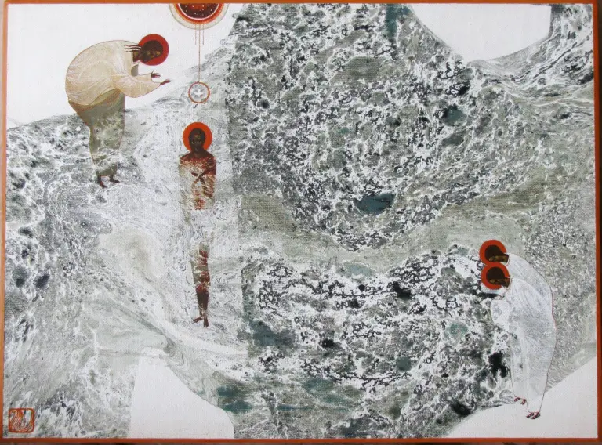

“Baptism of Jesus”

