Riverside Community Church
Ash Wednesday Service
March 2, 2022 7 pm

Gathering Music

Centering Silence & Prayer

Prelude “Ave Maria”

Words of Welcome

*Opening Song “When We Are Living” 2x

When We Are Living, it is in Christ Jesus,
and when we’re dying, it is in the Lord.
Both in our living and in our dying,
we belong to God, we belong to God.

Preparing Our Hearts

Readings “Room to Grow” Meister Eckhart
“Keeping Quiet” Pablo Neruda

Choral Anthem “Just As I Am” Elliot, Bradbury & Carter

Bible Bits & Scripture Isaiah 58: 1-12 Matthew 6:19-21

Words of Reflection

Song of Response “Nothing Can Trouble” 3x.

Nothing can trouble, nothing can frighten.
Those who seek God shall ever go wanting.
God alone fills us.

A Time of Blessing “Blessing the Dust”

A Time to Remember
You are invited to come forward and receive the mark of ashes—as a reminder of your existence as a finite, vulnerable and beloved child of God, and as a sign of your desire for wholeness and healing.

*Closing Song “Take, O Take Me as I Am” 2x.

Take, O take me as I am;
summon out what I shall be;
set your seal upon my heart and live in me.

Benediction
Following the benediction, you are invited to
depart the sanctuary in silence or
remain for a time of reflection
Would you become a pilgrim on the road of Love?
The first condition is that you make yourself
humble as dust and ashes.
Ansarit of Herat

Rev. Vicky Stifter, Minister
Diana Beterbide, Piano & Choir Director
Dawn Rankin, Flute
Betty Shalhope & Eileen Utroske, Diaconate Leaders
Kathy Watson & Heather Nielsen, Readers
Tom Hackett, Sound & Audio Visual System

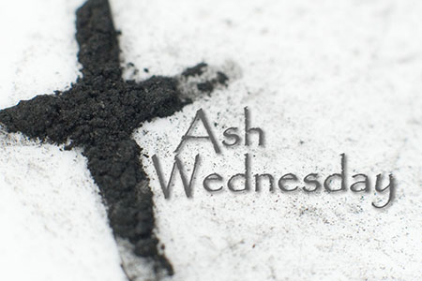

RIVERSIDE COMMUNITY CHURCH
Ash Wednesday Service
March 2, 2022
7 pm

